SCREEN SHOTS:

HOME PAGE:

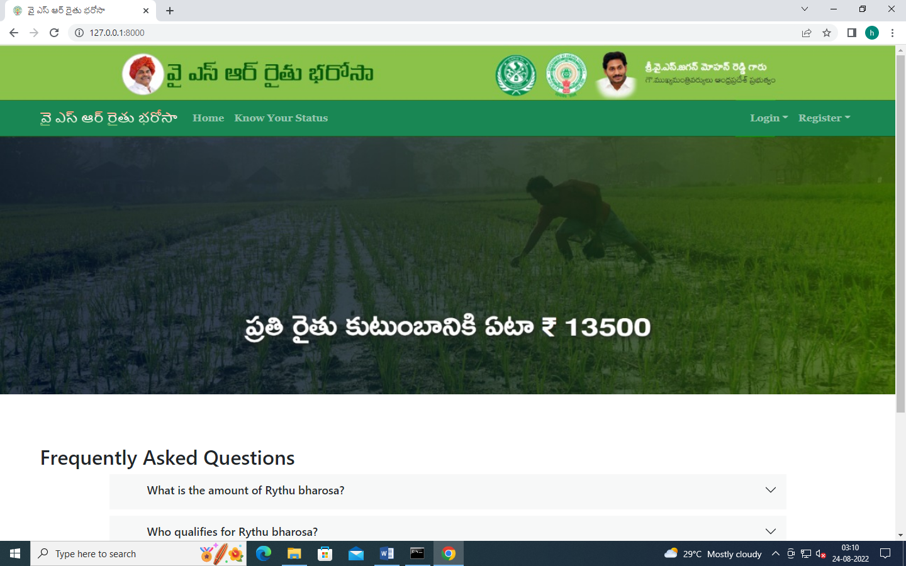

FARMER REGISTRATION

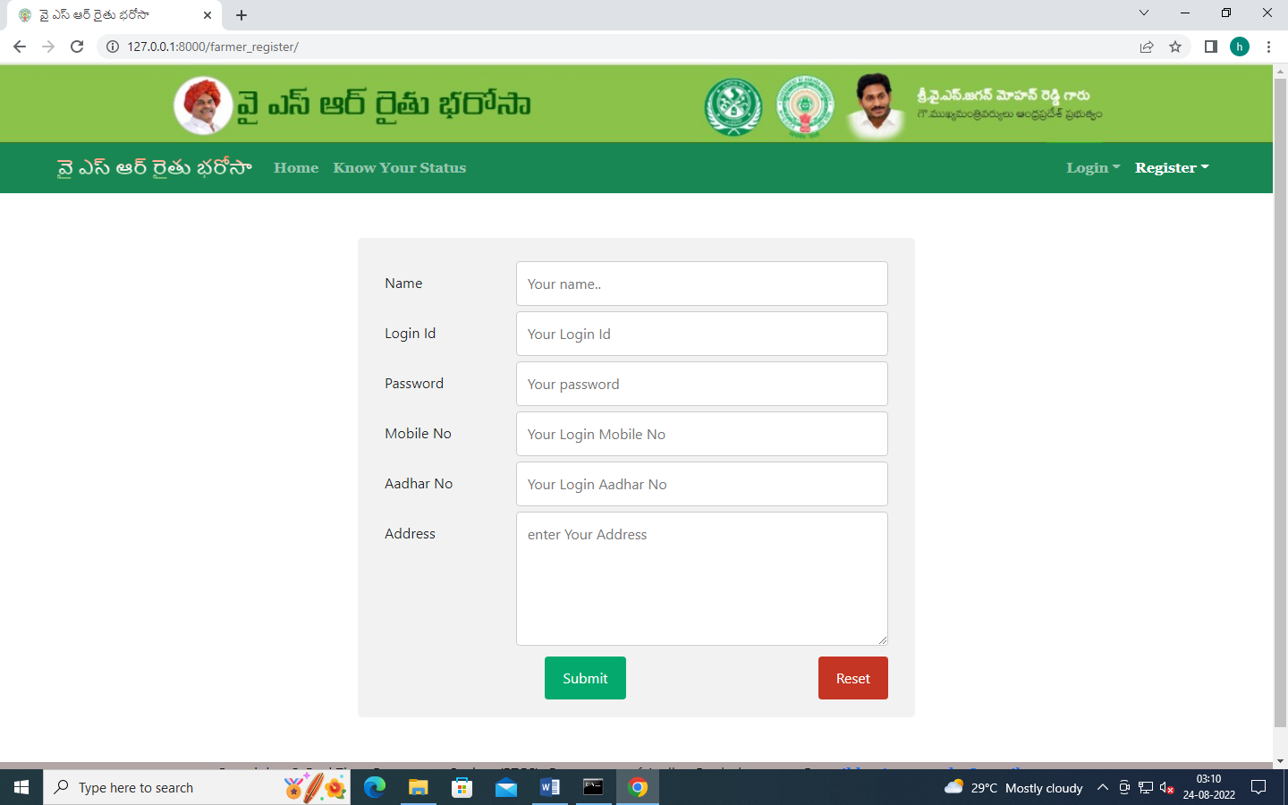

FAMER LOGIN:

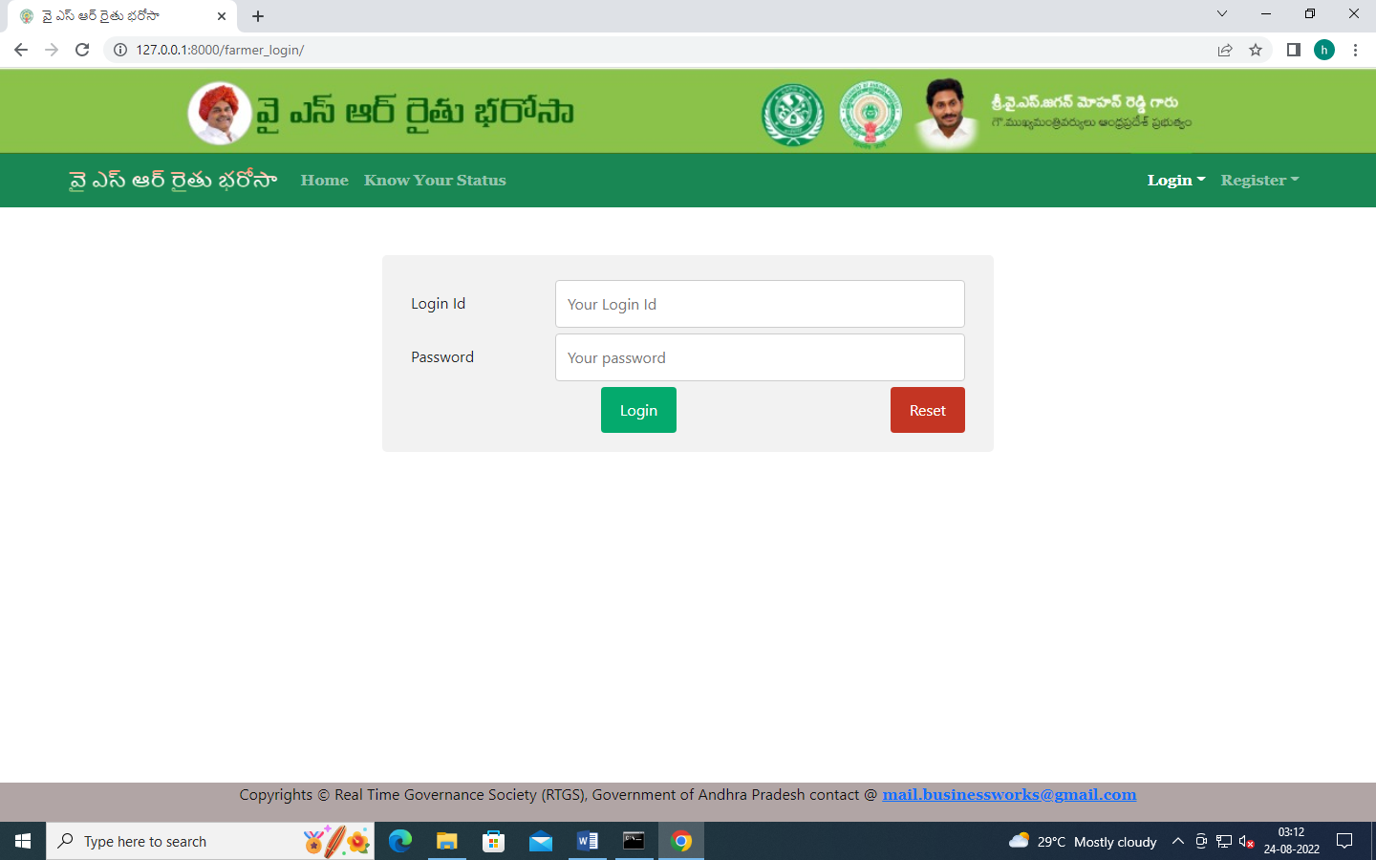

FARMER HOME:

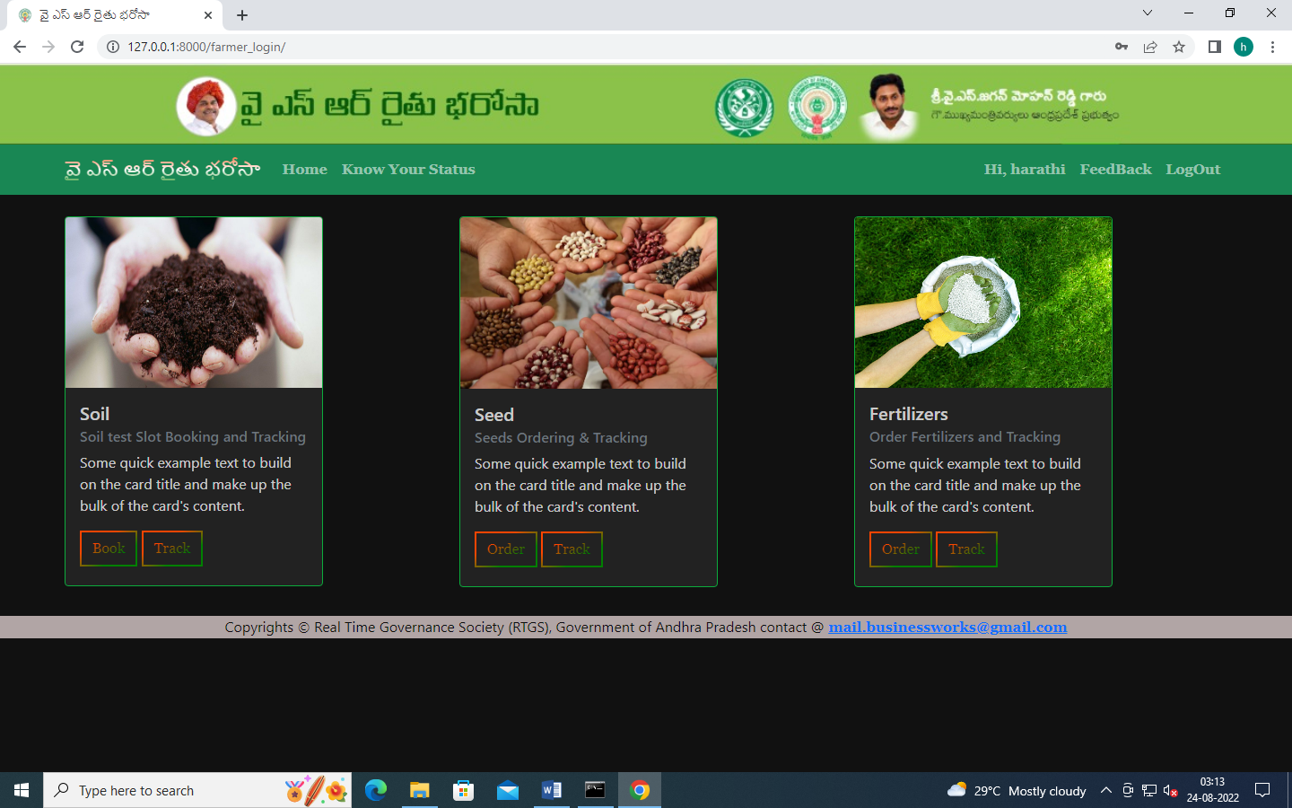

FARMER SOIL TEST SLOT BOOKING

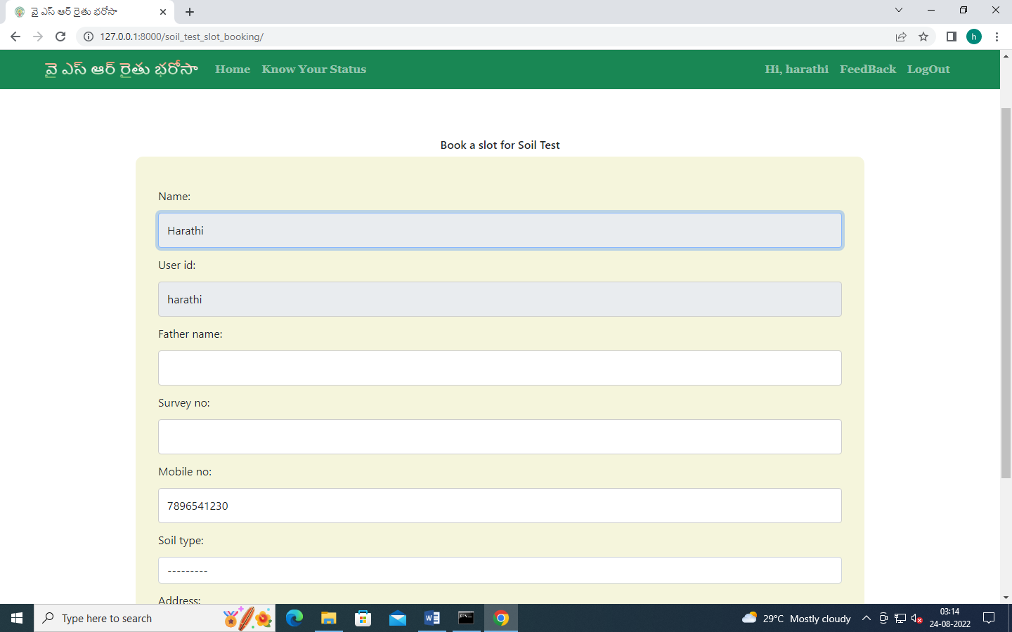

FARMER SOIL TEST SLOT BOOKING TRACKING ID:

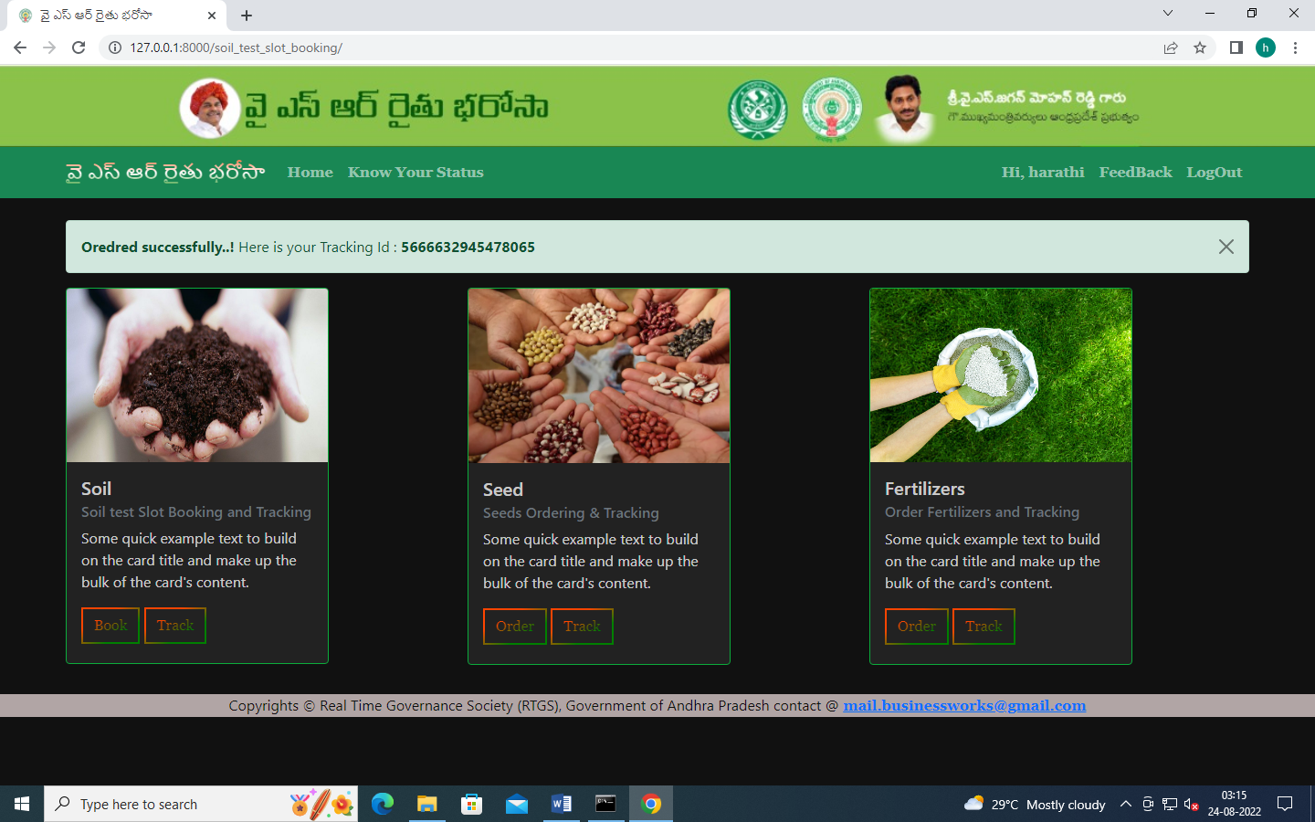

FARMER SOIL TEST TRACKING:

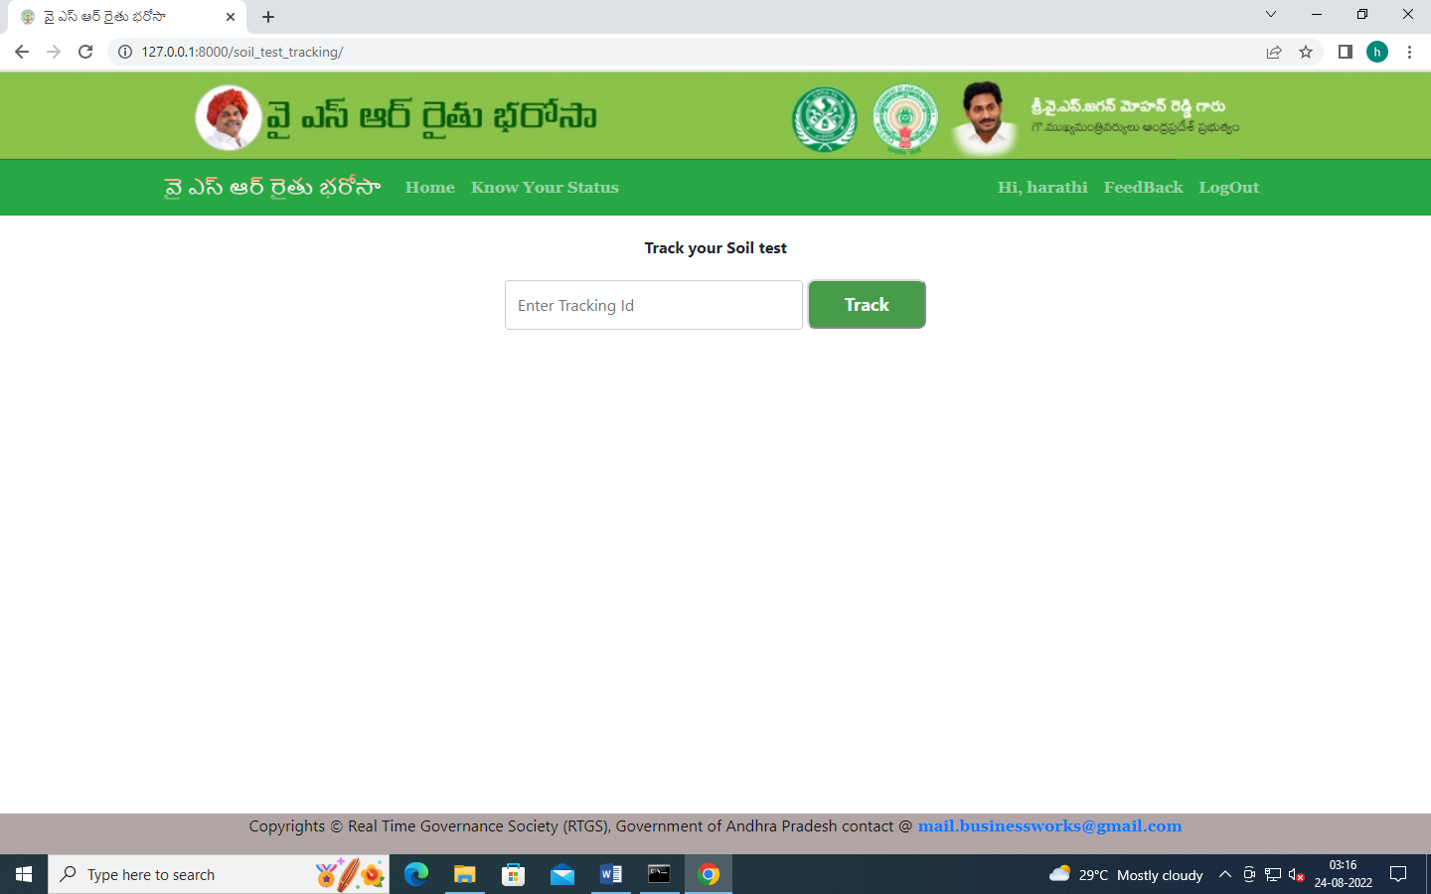

FARMER SEED ORDERING:

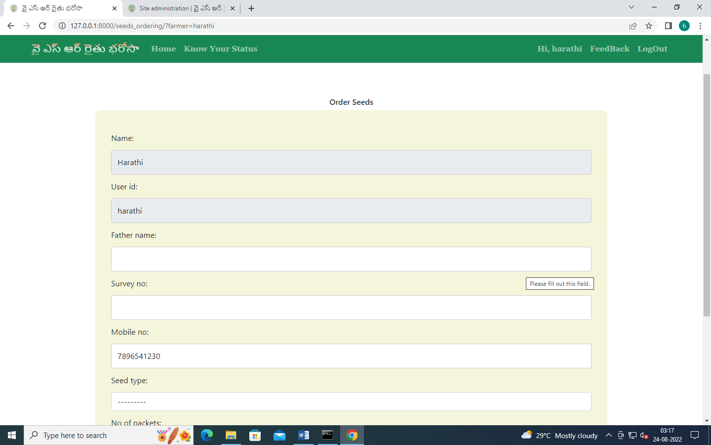

FARMER SEED ORDERING CONFIRMATION AND TRACKING ID:

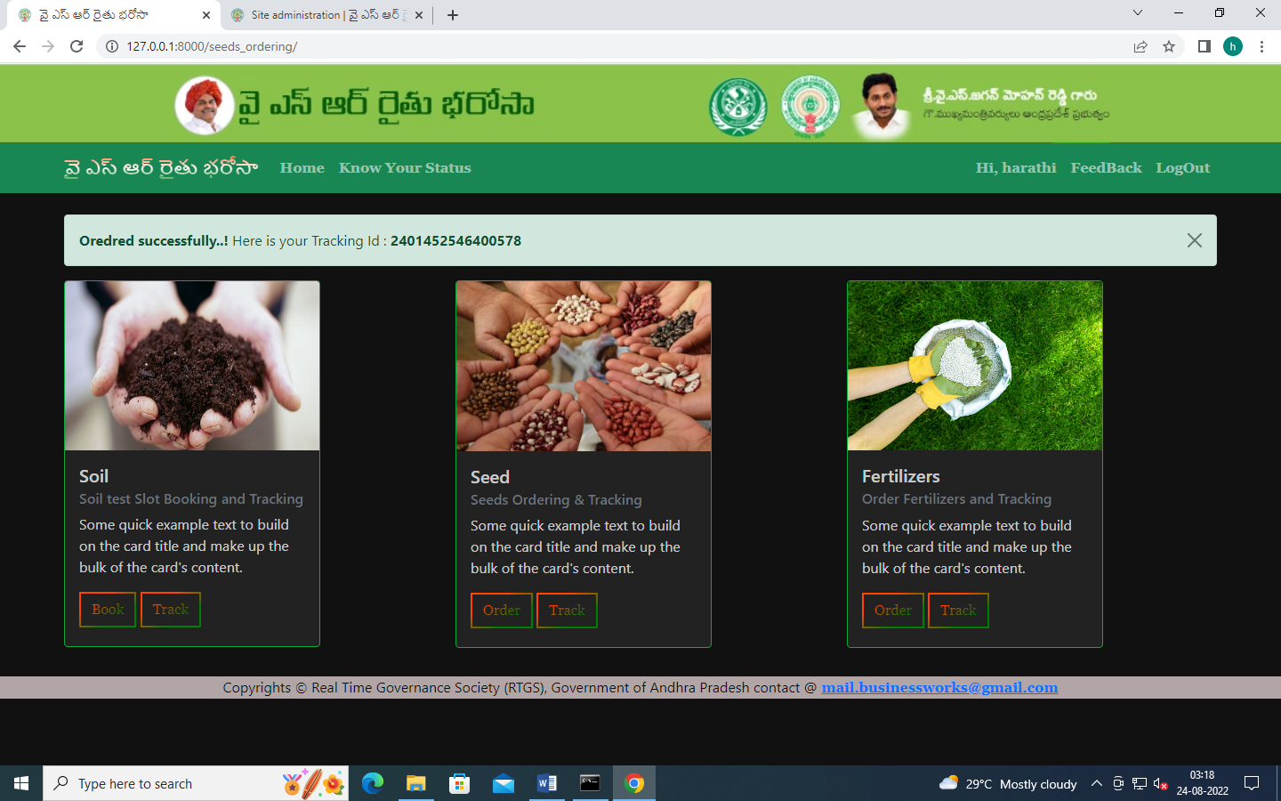

FARMER SEEDS ORDER TRAKING:

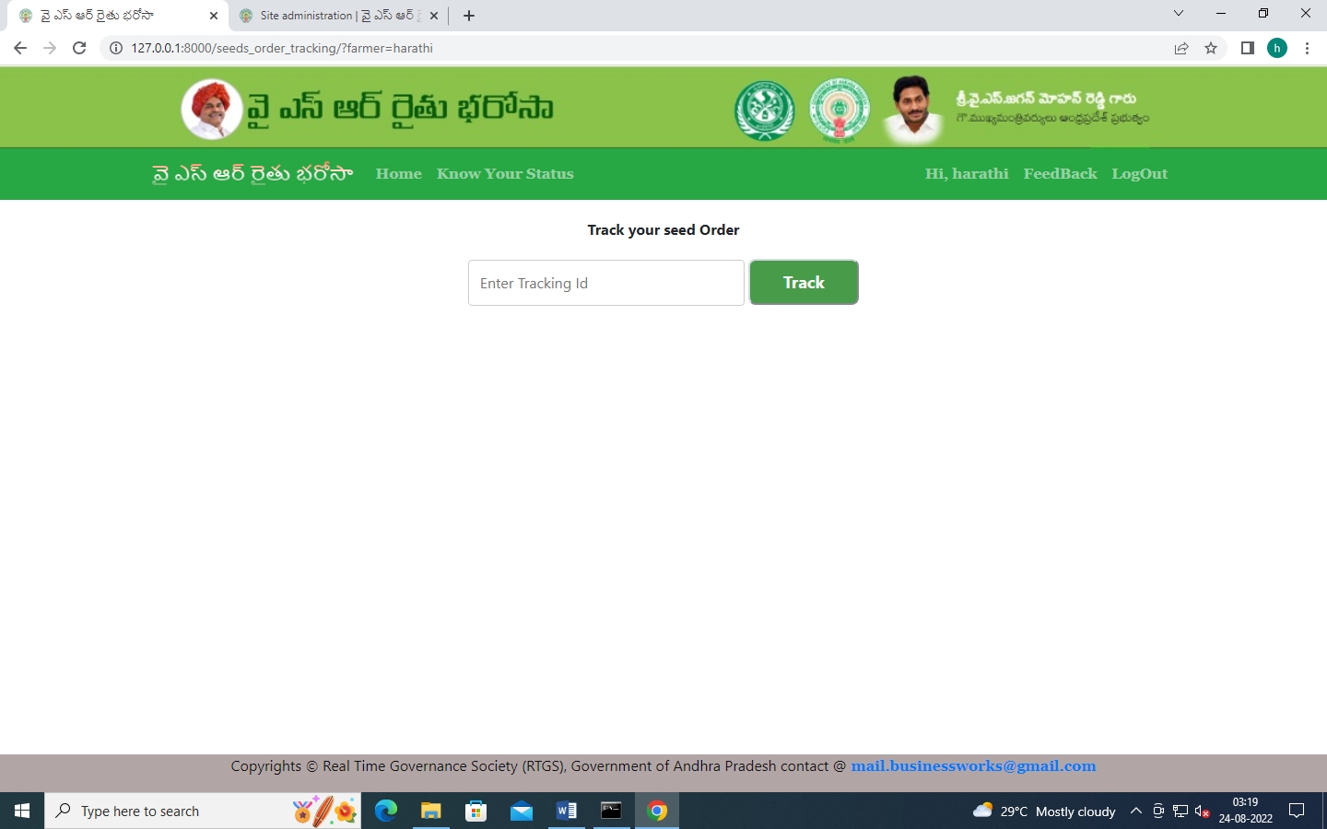

FARMER ORDERING FERTILIZERS:

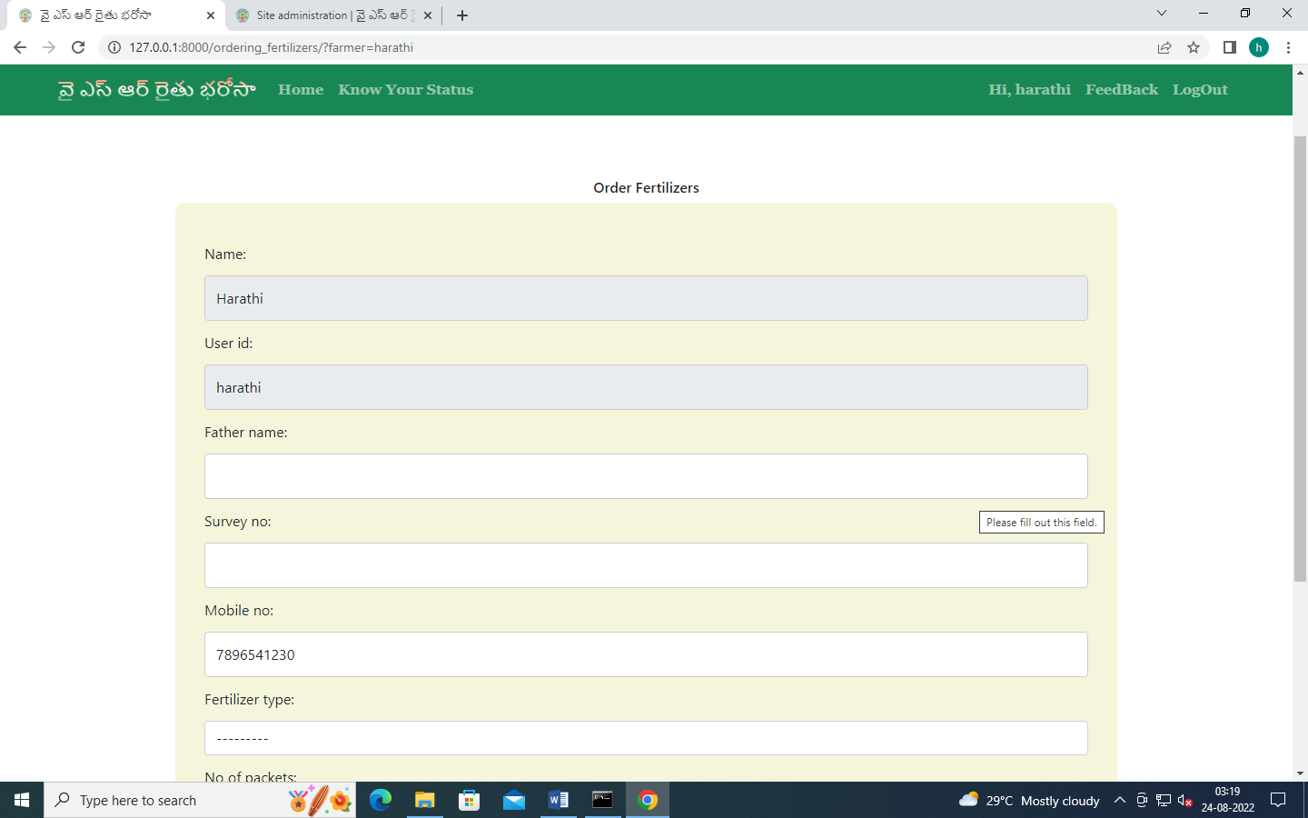

FARMER FERTILIZERS TRACKING:

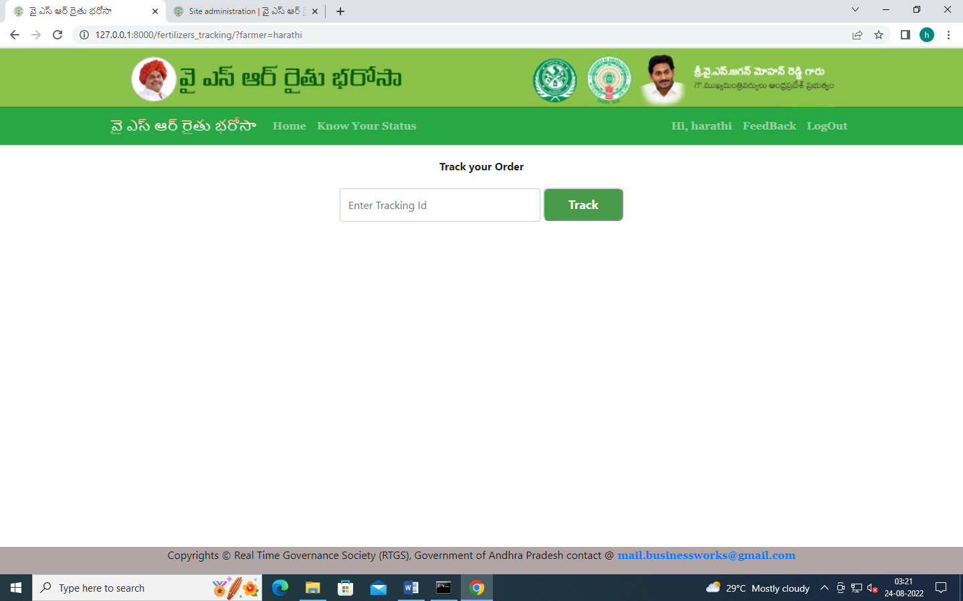

FARMER FEEDBACK:

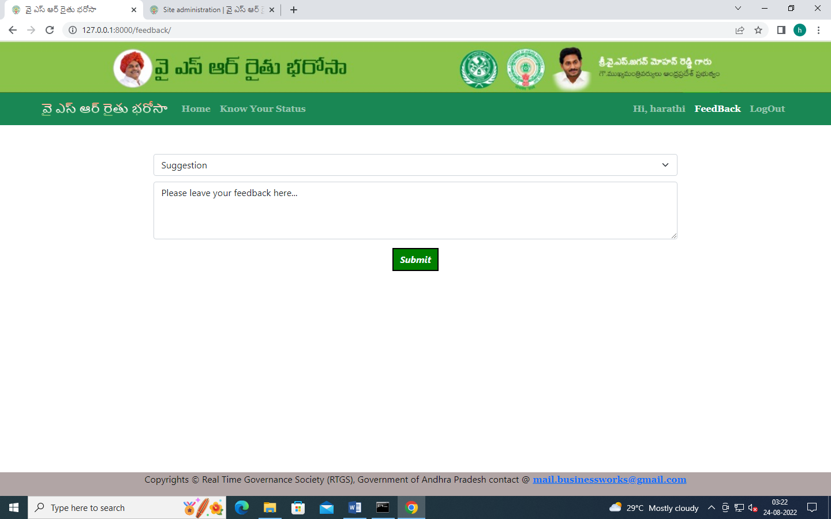

ADMIN LOGIN:

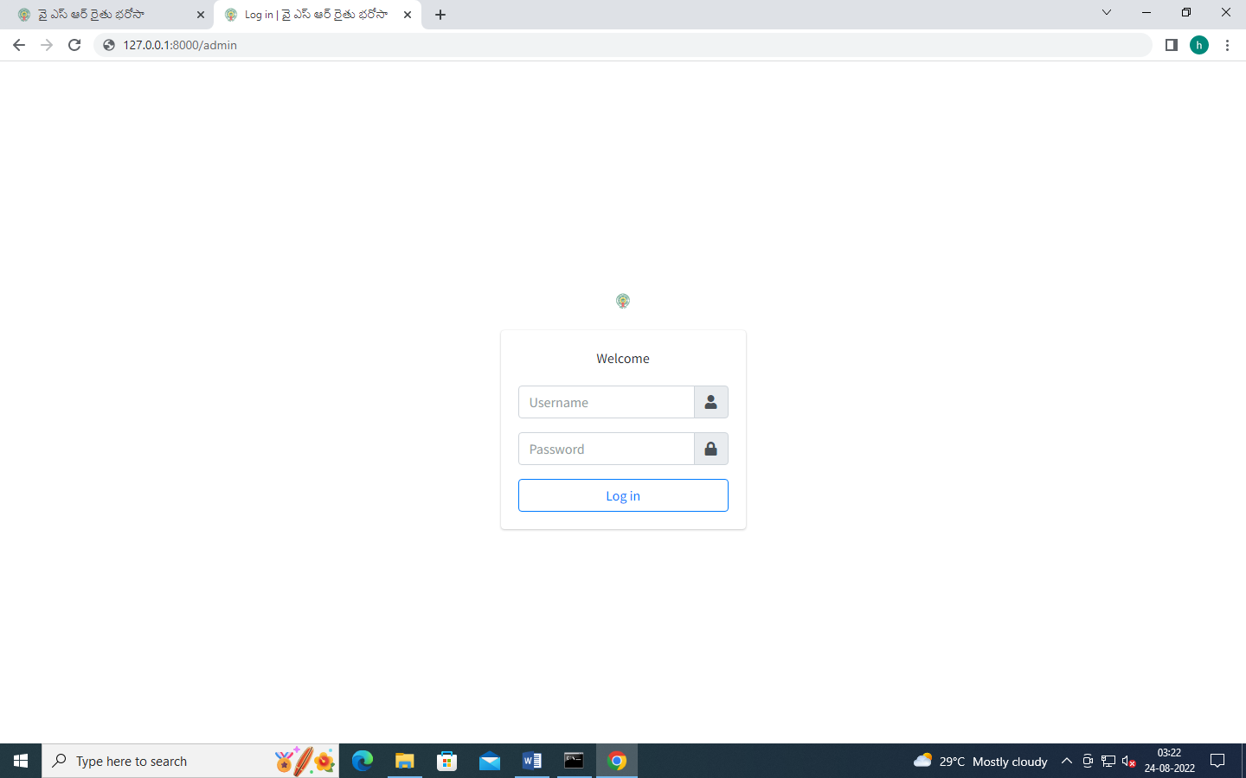

ADMIN DASHBOARD:

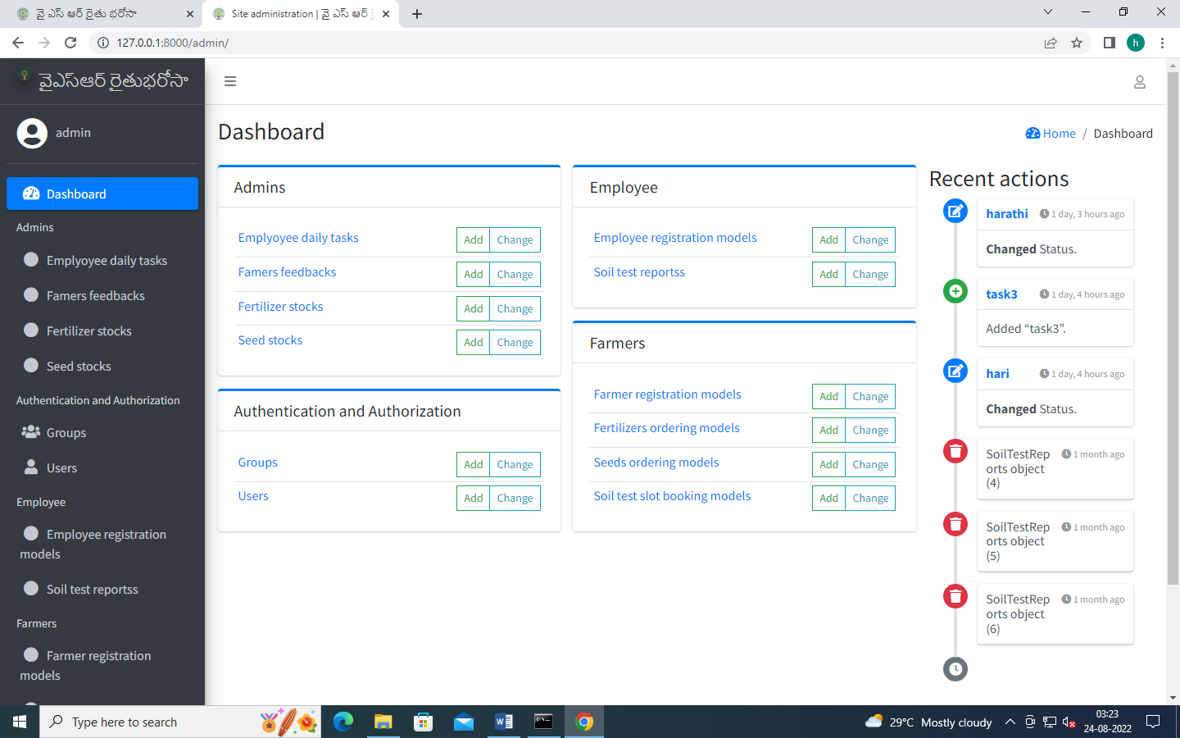

ADMIN FERTILIZER STOCKS UPDATE:

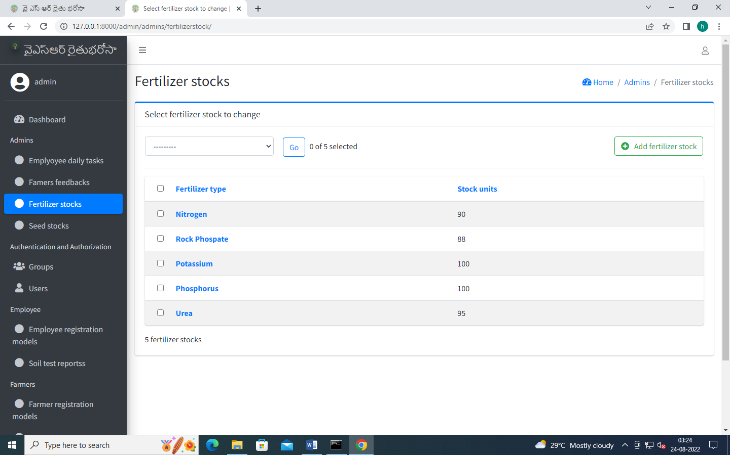

ADMIN SEED STOCK UPDATE:

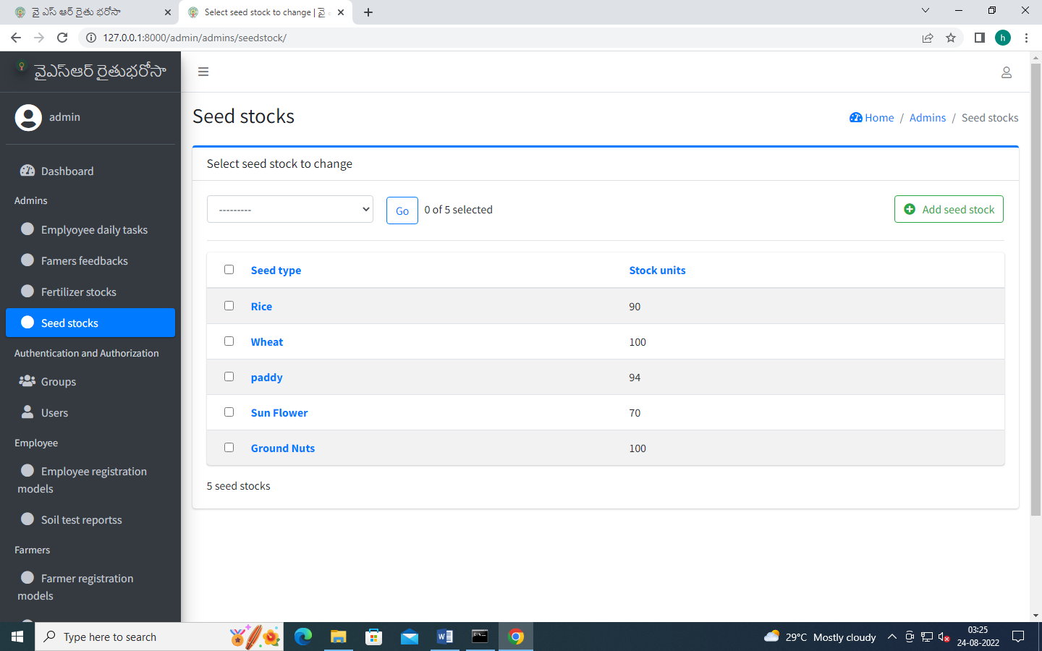

FERTILIZER ORDERS UPDATE:

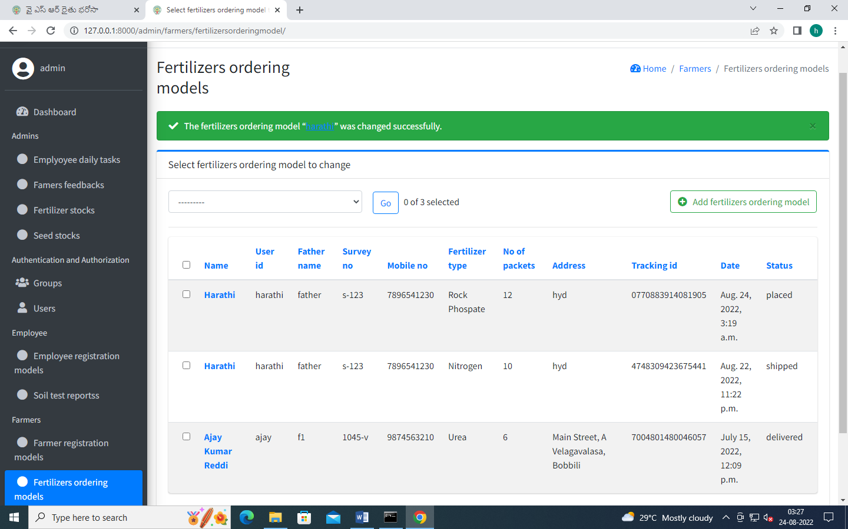

SEEDS ORDERS UPDATE:

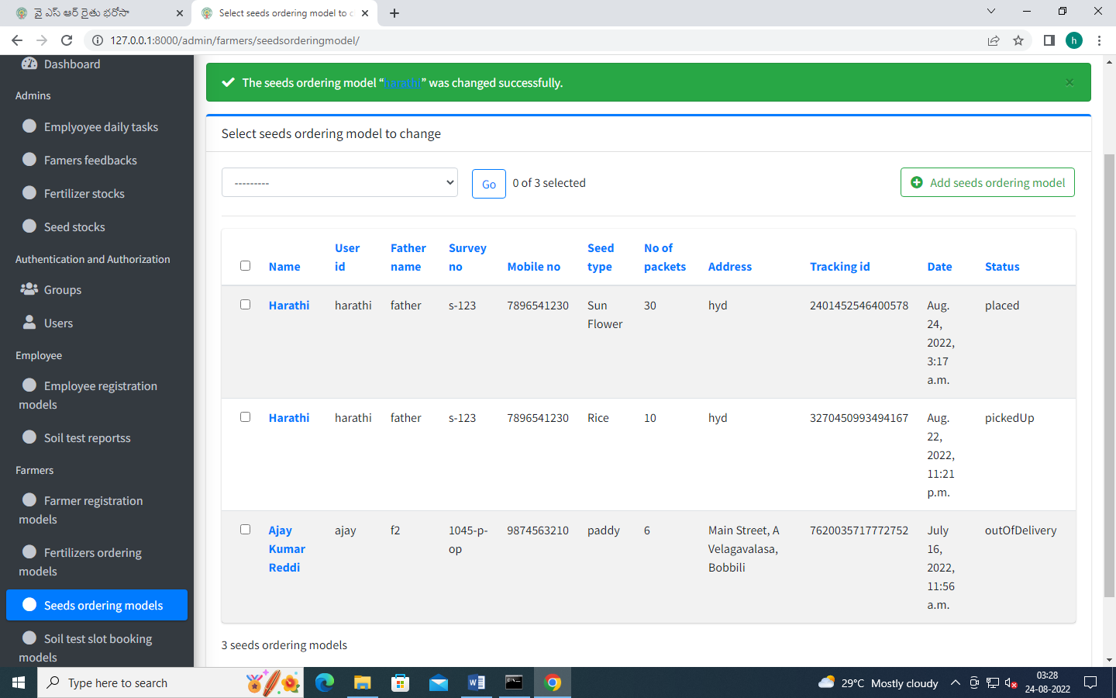

SOIL TEST SLOT UPDATE:

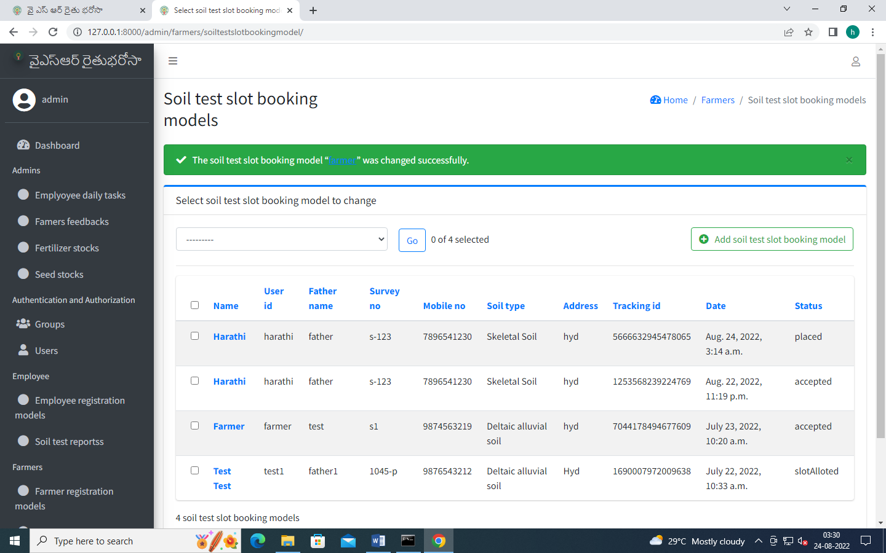

CHECK FARMERS FEEDBACK:

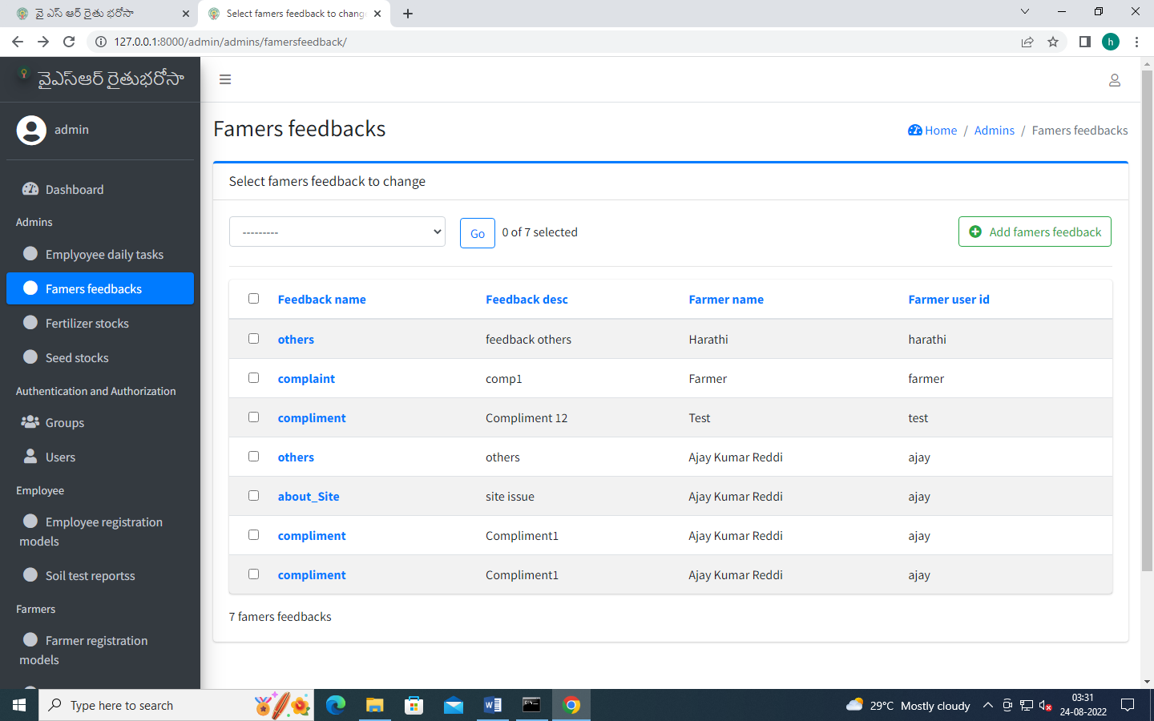

EMPLOYEE REGISTER:

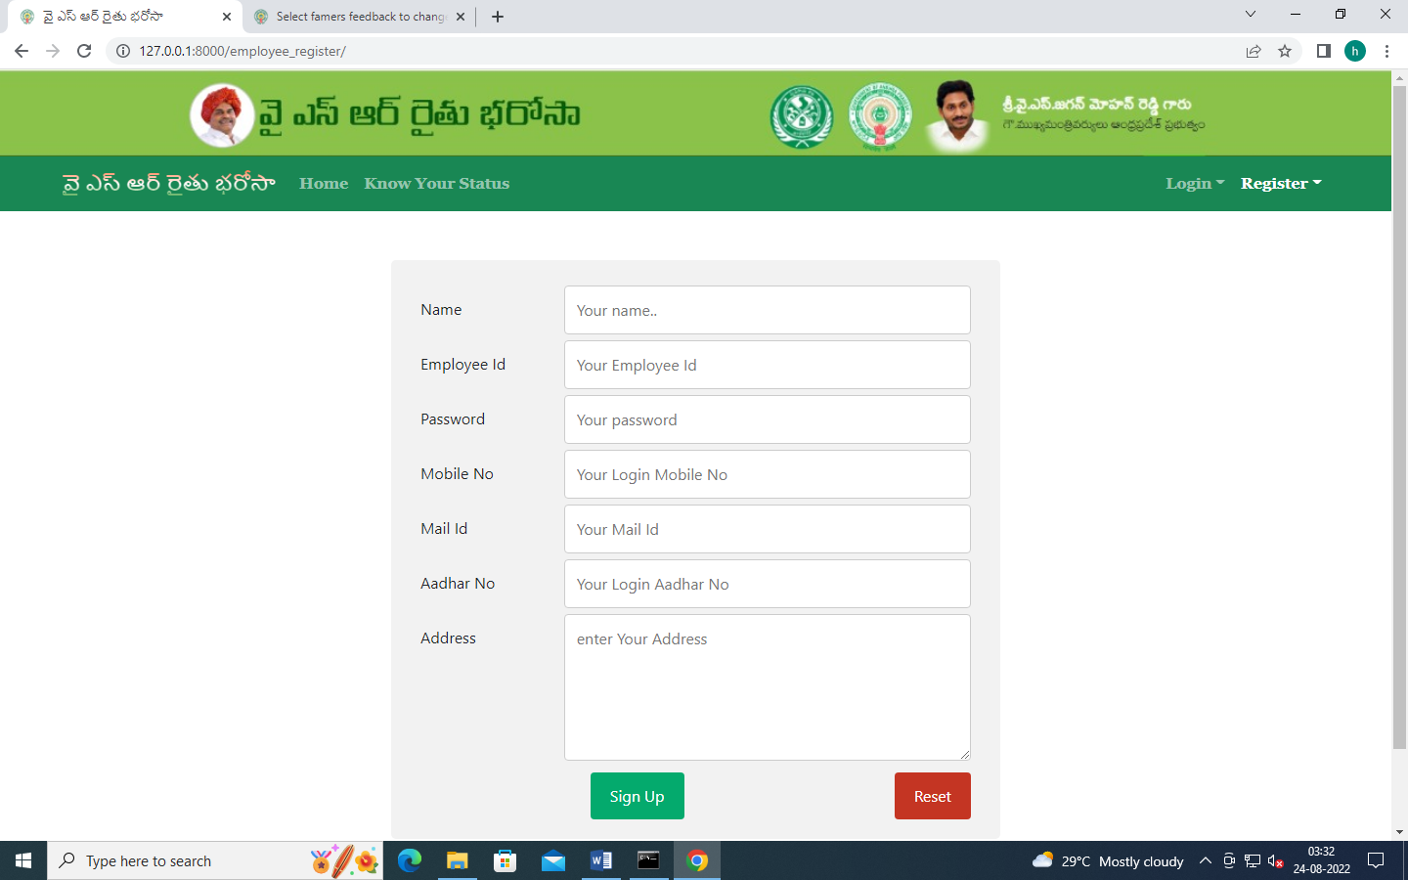

ADMIN ACTIVATES EMPLOYEE;

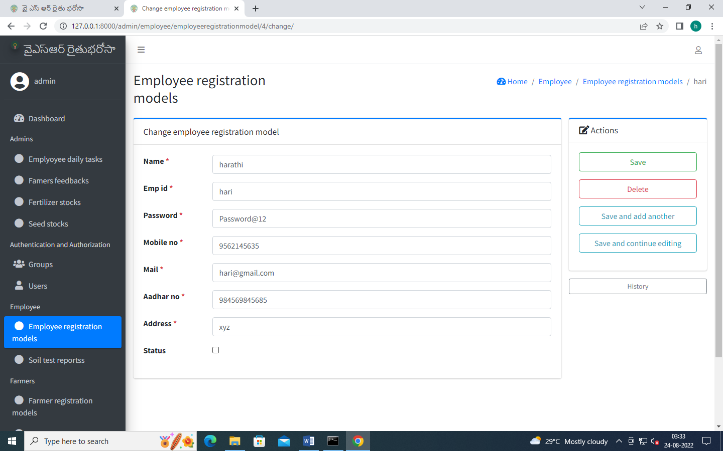

EMLOYEE LOGIN:

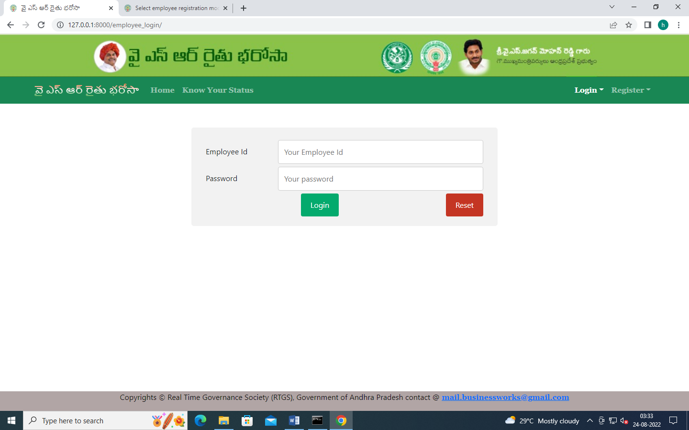

EMPLOYEE HOME:

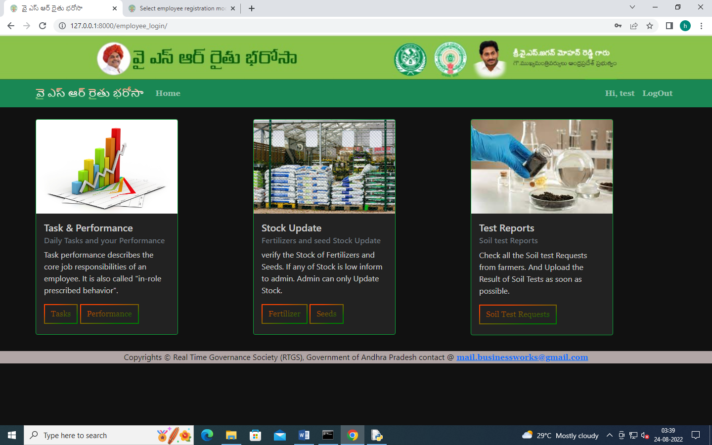

EMPLOYEE DAILY TASKS:

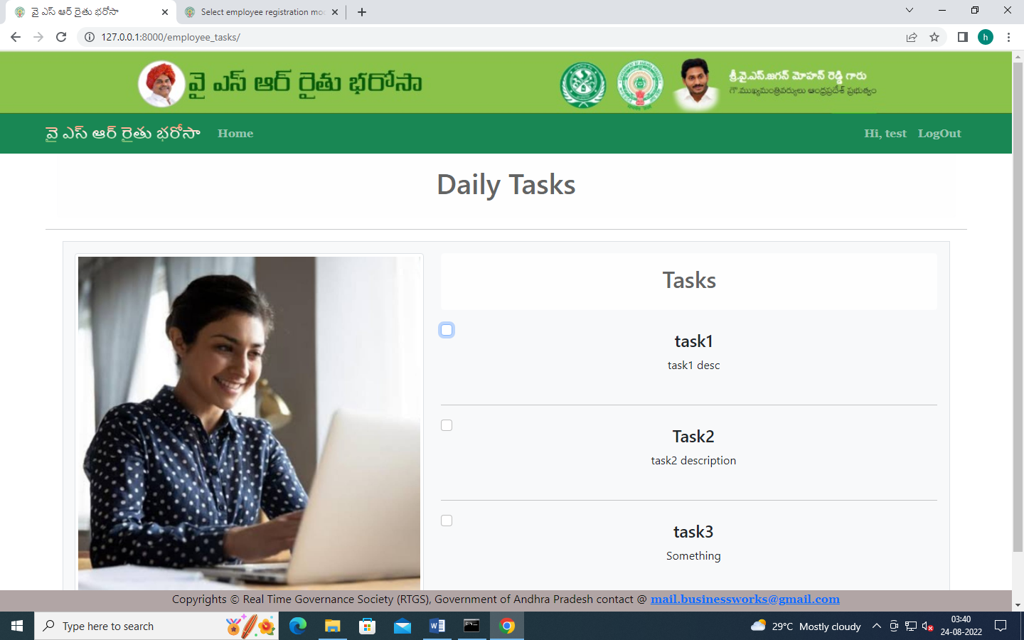

EMPLOYEE PERFORMANCE:

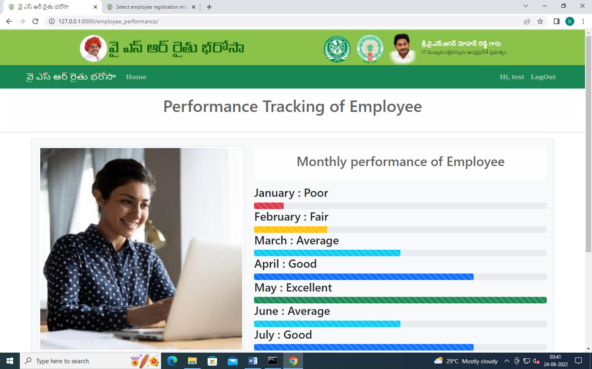

EMPLOYEE CHECKING FERTILIZER STOCKS:

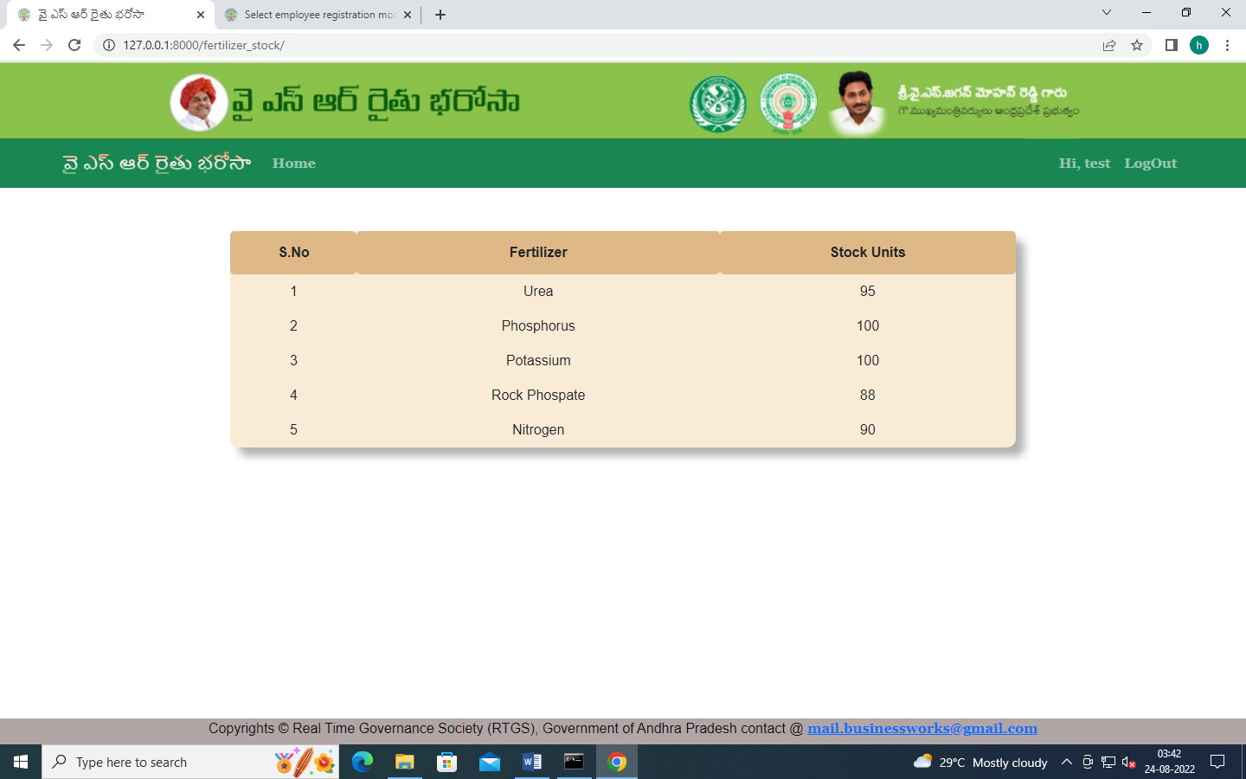

EMPLOYEE CHECKING SEED STOCK:

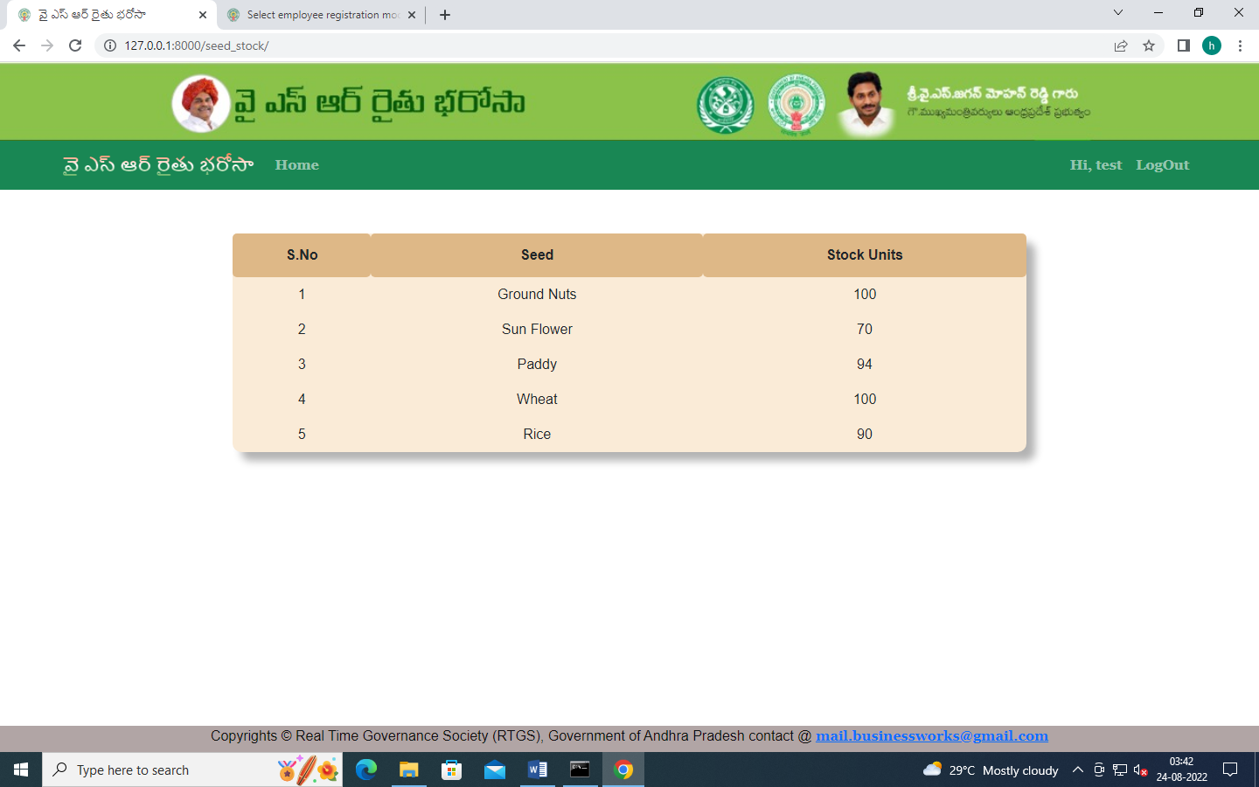

EMPLOYEE CHECKING SOILTEST REQUESTS:

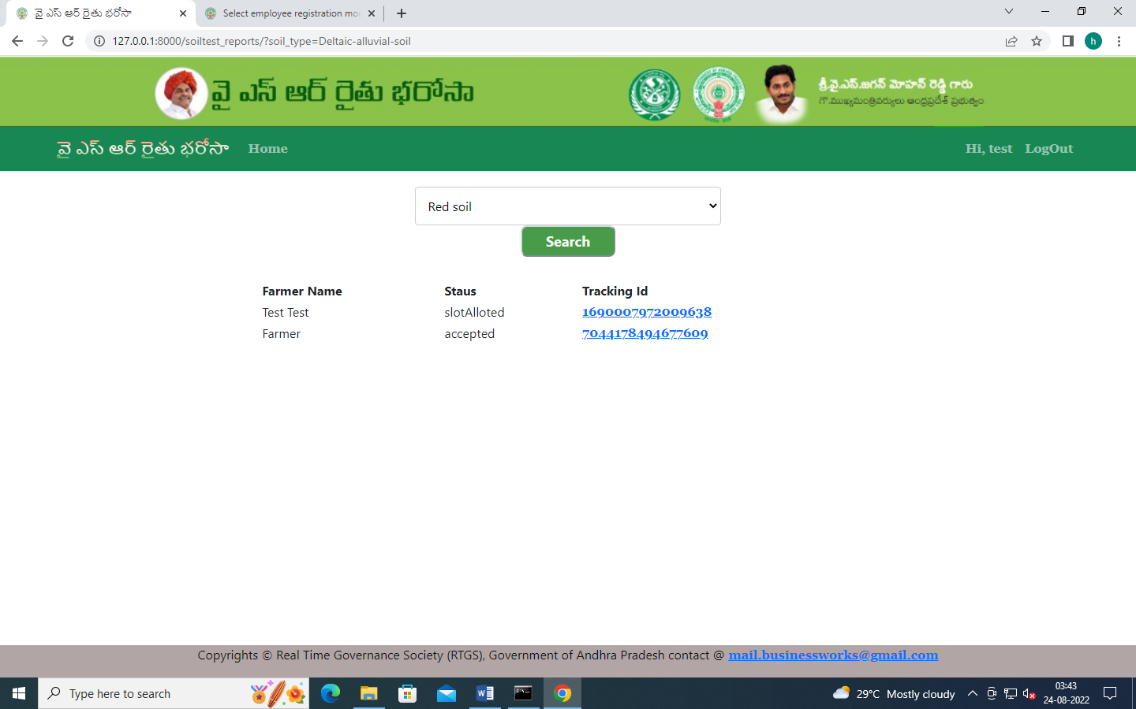

EMPLOYEE UPDATES SOIL TEST REPORTS:



ADMIN UPDATES EMLOYEE DAILY TASKS:

